Laboratory 3: Network Traffic Prediction (Supervised Learning)
ITAI-4370 — AI 5/6G Communications & ORAN Networks
Instructor: Tawanda Chiyangwa

Objective
The goal of this lab is to build a machine learning model that predicts network traffic levels using historical hourly data. A Random Forest Regressor is trained on a full year of synthetic telecom traffic data that includes realistic daily, weekly, and seasonal usage patterns.

Background
Network traffic is not random. It tends to be higher during business hours on weekdays, lower on weekends, and shifts slightly across seasons. Machine learning models can learn these patterns from historical data and make accurate predictions about future traffic.
In this lab, a year of hourly traffic data is generated with built-in daily and weekly cycles, then enriched with engineered features like lag values and rolling averages. A Random Forest model is trained on 80% of the data and tested on the remaining 20%, with performance measured using Mean Squared Error (MSE) and R-squared (R²).

Python Code
import numpy as np
import pandas as pd
import matplotlib.pyplot as plt
from sklearn.model_selection import train_test_split
from sklearn.ensemble import RandomForestRegressor
from sklearn.metrics import mean_squared_error, r2_score
import seaborn as sns

# Generate synthetic telecom traffic data
np.random.seed(42)
dates = pd.date_range(start='2023-01-01', end='2023-12-31', freq='H')
n_samples = len(dates)

# Create realistic traffic patterns
hour = dates.hour
day_of_week = dates.dayofweek
day_of_year = dates.dayofyear

# Base traffic with daily and weekly patterns
base_traffic = (
50 +
20 * np.sin(2 * np.pi * hour / 24) +
10 * np.sin(2 * np.pi * day_of_week / 7) +
5 * np.sin(2 * np.pi * day_of_year / 365) +
np.random.normal(0, 5, n_samples)
)

# Add business hours boost
business_hours = (hour >= 9) & (hour <= 17) & (day_of_week < 5)
base_traffic += business_hours * 15

# Create DataFrame
traffic_data = pd.DataFrame({
'timestamp': dates,
'hour': hour,
'day_of_week': day_of_week,
'is_weekend': day_of_week >= 5,
'is_business_hours': business_hours,
'traffic_gbps': np.maximum(base_traffic, 0)
})

# Feature engineering
traffic_data['traffic_lag_1h'] = traffic_data['traffic_gbps'].shift(1)
traffic_data['traffic_lag_24h'] = traffic_data['traffic_gbps'].shift(24)
traffic_data['traffic_rolling_7d'] = traffic_data['traffic_gbps'].rolling(
window=24*7, center=True).mean()
traffic_data = traffic_data.dropna()

# Train/test split
feature_columns = ['hour', 'day_of_week', 'is_weekend', 'is_business_hours',
'traffic_lag_1h', 'traffic_lag_24h', 'traffic_rolling_7d']
X = traffic_data[feature_columns]
y = traffic_data['traffic_gbps']
X_train, X_test, y_train, y_test = train_test_split(
X, y, test_size=0.2, random_state=42, shuffle=False)

# Train Random Forest model
rf_model = RandomForestRegressor(
n_estimators=100, max_depth=10, random_state=42, n_jobs=-1)
rf_model.fit(X_train, y_train)

# Evaluate
y_pred_train = rf_model.predict(X_train)
y_pred_test = rf_model.predict(X_test)
print(f"Training MSE: {mean_squared_error(y_train, y_pred_train):.2f}")
print(f"Testing MSE: {mean_squared_error(y_test, y_pred_test):.2f}")
print(f"Training R2: {r2_score(y_train, y_pred_train):.3f}")
print(f"Testing R2: {r2_score(y_test, y_pred_test):.3f}")

Program Output
Dataset shape: (8570, 9)

First few rows:
hour day_of_week is_weekend is_business_hours traffic_gbps traffic_lag_1h traffic_lag_24h traffic_rolling_7d
84 12 2 False True 71.050823 77.678321 70.680542 54.166101
85 13 2 False True 67.408125 71.050823 66.971737 54.147588
86 14 2 False True 69.670302 67.408125 57.544738 54.132844

Model Performance:
Training MSE: 17.59
Testing MSE: 34.64
Training R2: 0.946
Testing R2: 0.893

Feature Importance:
feature importance
traffic_lag_1h 0.8157
hour 0.0777
traffic_lag_24h 0.0357
day_of_week 0.0278
traffic_rolling_7d 0.0234
is_business_hours 0.0175
is_weekend 0.0022

Output Graphs

Traffic Pattern Visualizations
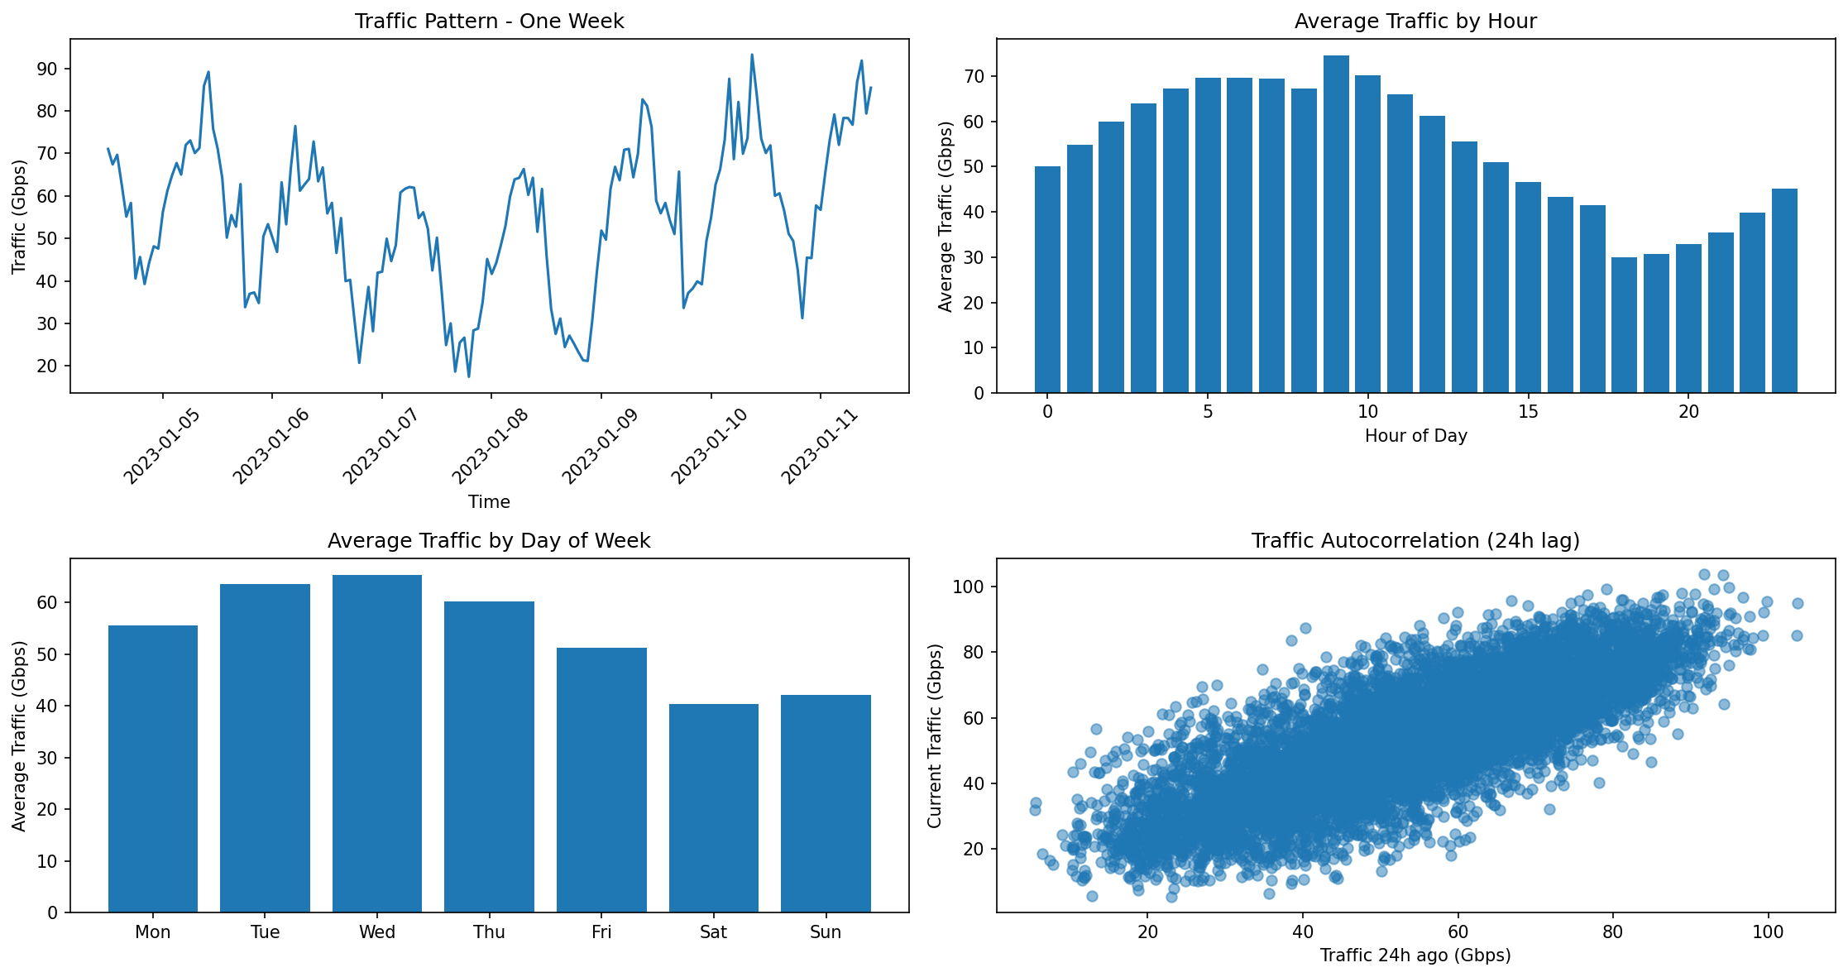
Figure 1: Traffic patterns broken down by week, hour of day, day of week, and 24-hour autocorrelation

Prediction Results and Feature Importance
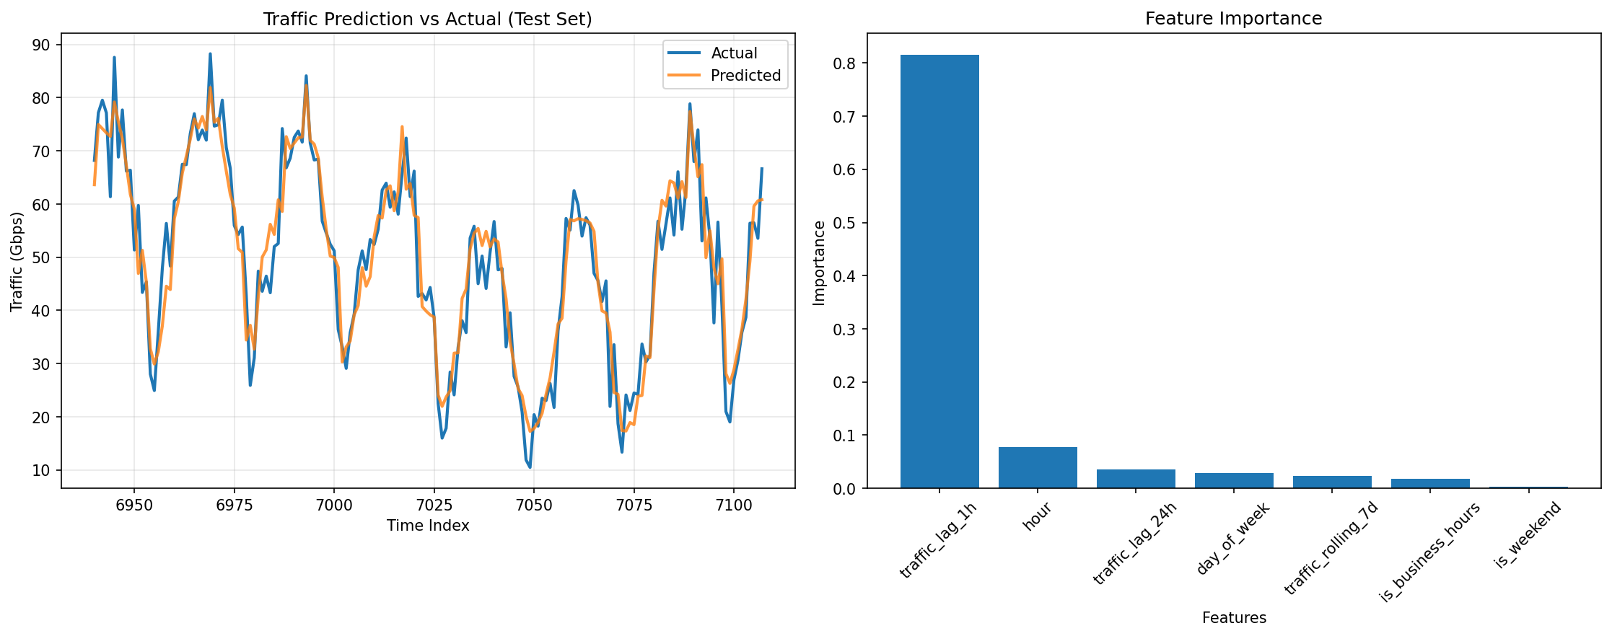
Figure 2: Predicted vs. actual traffic on the test set, and feature importance rankings

Analysis
The model performed well on both the training and test sets. A Training R² of 0.946 means the model explains about 95% of the variance in the training data. The Test R² of 0.893 shows it still generalizes well to data it has never seen, which means it is not just memorizing the training set.
The most important feature by a wide margin was traffic_lag_1h at 81.6%. That makes sense — the traffic level from one hour ago is the strongest clue about what traffic is doing right now. Hour of day came in second at 7.8%, reflecting the daily usage cycle. The remaining features like day of week, 24-hour lag, and business hours flag contributed smaller but still meaningful amounts.
Looking at the prediction graph, the model tracks the actual traffic curve closely throughout the test period. The predicted line follows the ups and downs of real traffic well, with only minor deviations captured by the test MSE of 34.64.

Conclusion
This lab demonstrated how supervised machine learning can be applied to predict network traffic in a telecommunications context. By engineering time-based features from historical data and training a Random Forest model, it was possible to achieve a test R² of 0.893 — meaning the model explained about 89% of the variation in unseen traffic data. A model like this could be used in a real network to anticipate traffic spikes, allocate bandwidth ahead of time, or flag unusual patterns that fall outside expected ranges.

